MEASURING THE PULSE OF PROSPERITY: AN INDEX OF ECONOMIC FREEDOM ANALYSIS
PROJECT REPORT
- INTRODUCTION:
An index of economic freedom is a composite measure of the quality of political economic institutions across different jurisdiction.
1.1Overview
Scores and ranks in an index are based on criteria that the creators of the index judge as being relevant which vary from one index to another.

1.2PURPOSE:
An index of economic freedom compares the jurisdiction against each other for various aspects such as traded freedom judicial effectiveness and tax burden. These factors may be weighed for their influence on economic freedom and collated into a single score for ranking.
2.PROBLEM DEFINITION AND DESIGN THINKING:
2.1 EMPATHY MAP
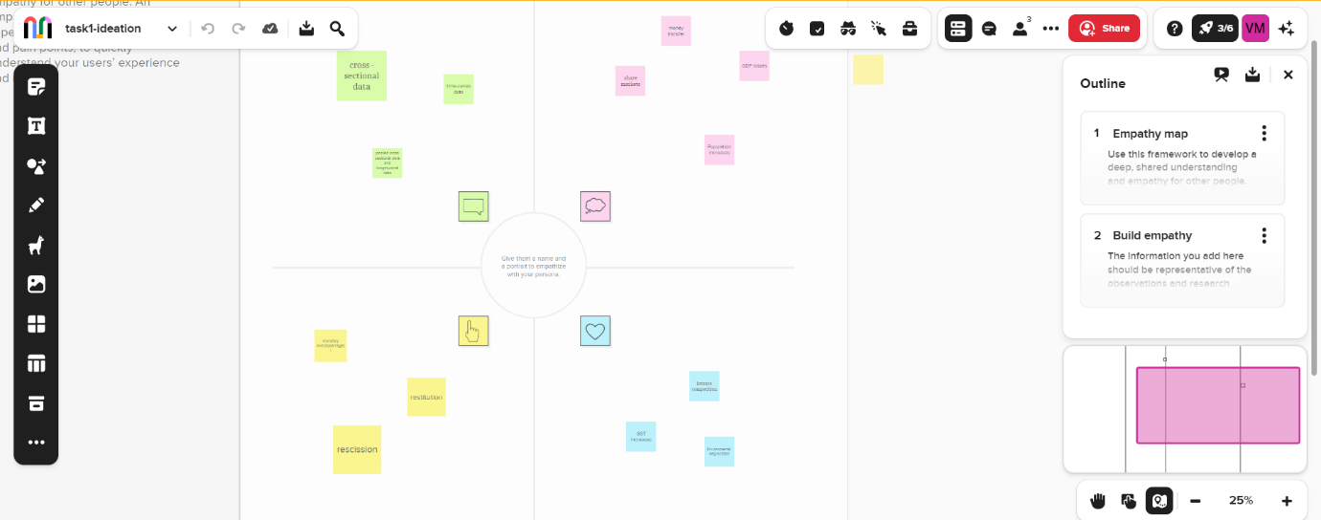
2.2Ideaton and brainstorming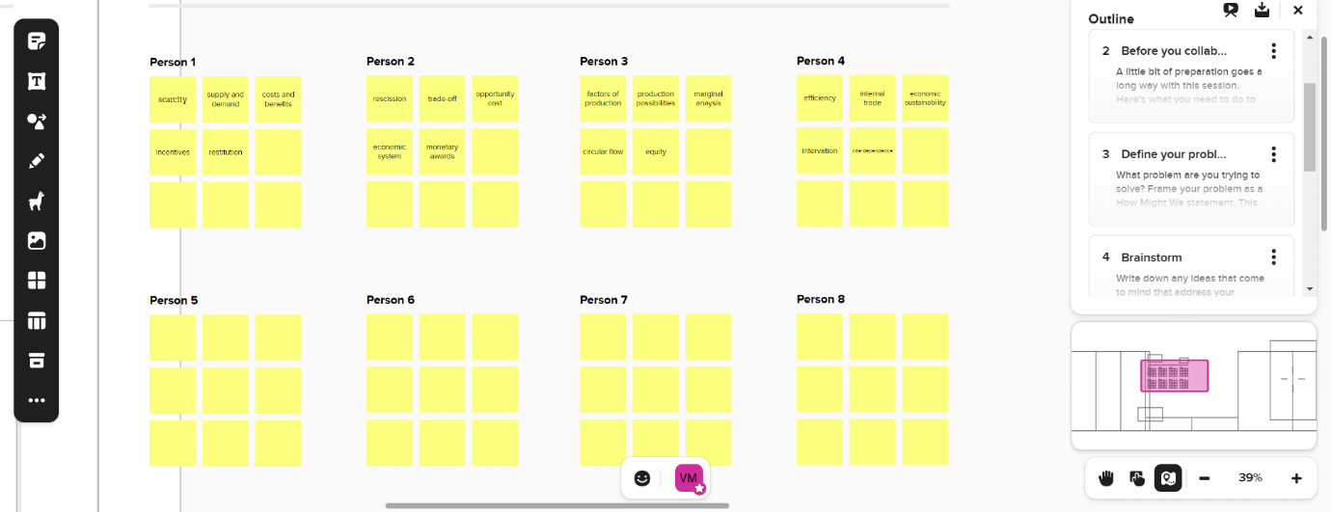
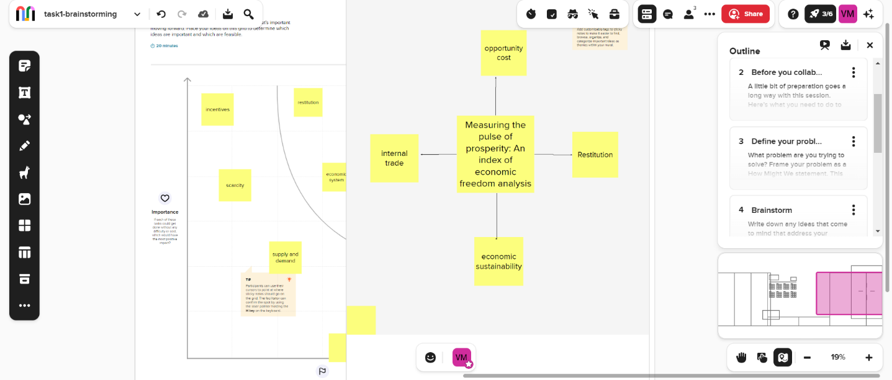

3.RESULT:
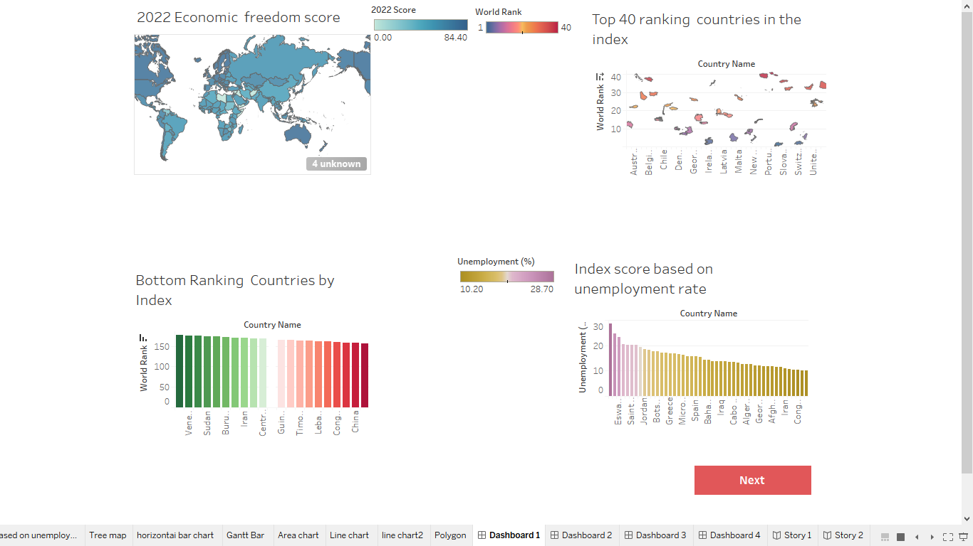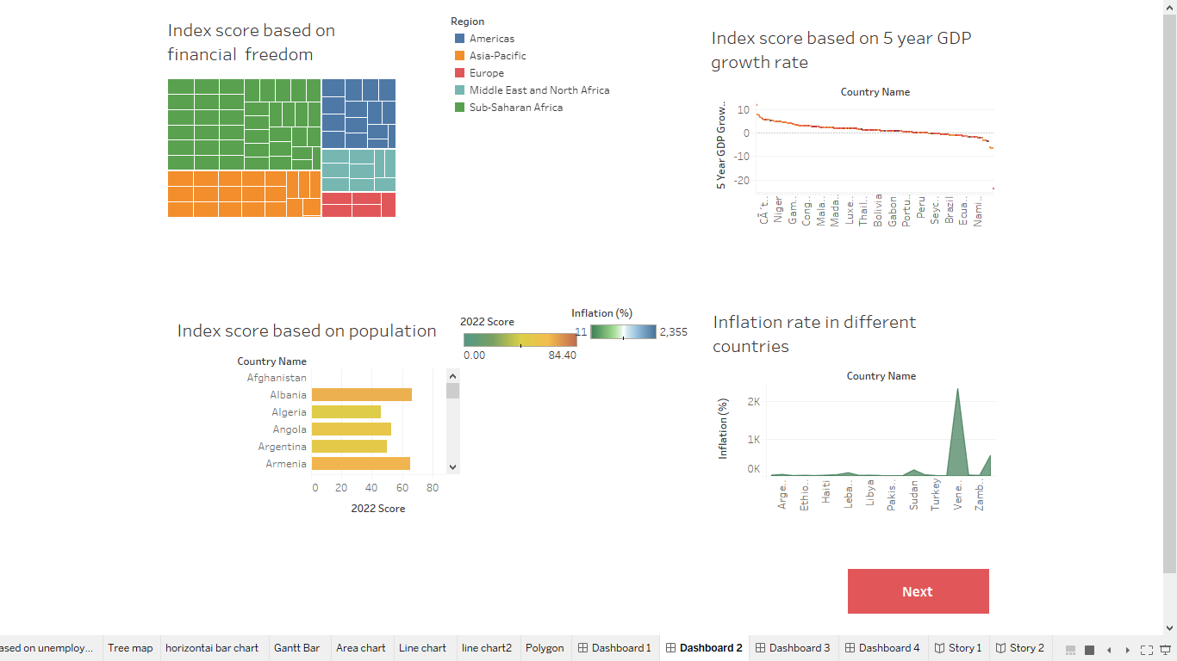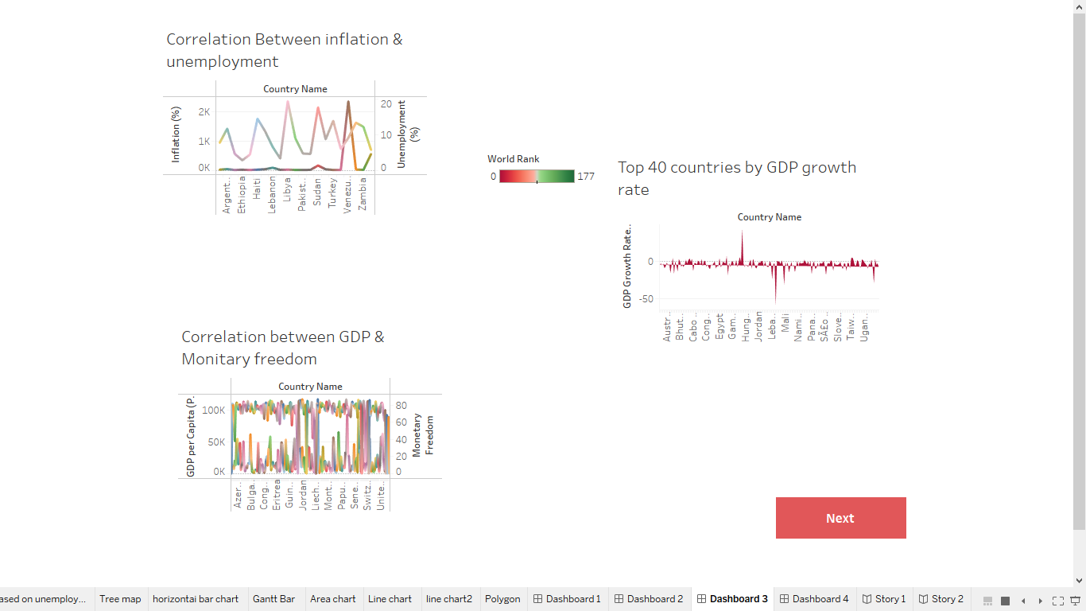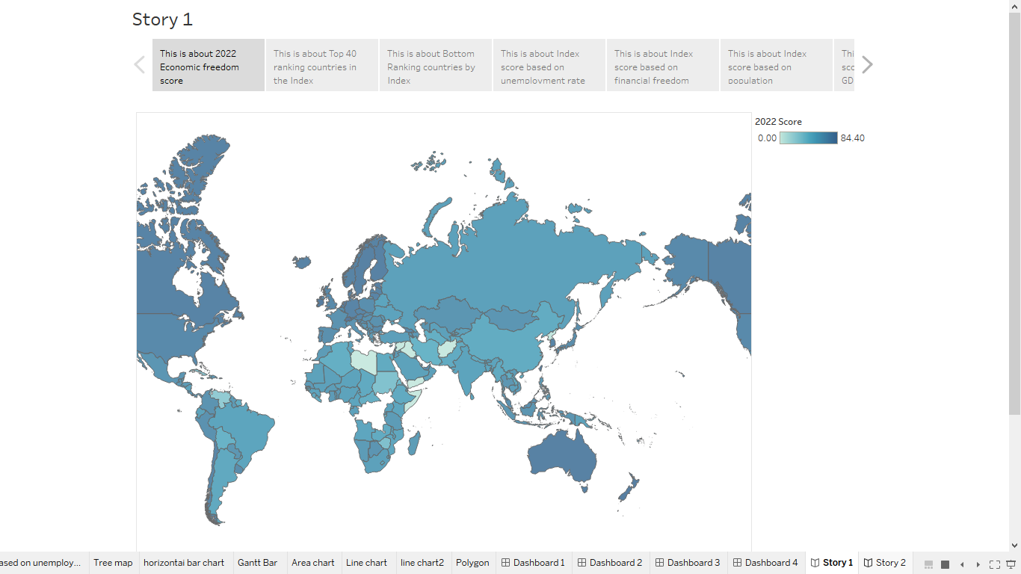

4.Advantages & disadvantages
Advantages
  - It is the most conductive to widespread prosperity.
  - Spurred innovation in health care, education and other so-called social goods.

Disadvantages
- Goods and services that are not profitable will not be produced or run.
- Excessive Merits power of firms.
- Unemployment and inequality.

5.APPLICATIONS
- Personal choice.
- Protection of persons and their property from aggression by others.

6.CONCLUSION
All economic systems are designed to manage the production, consumption, and distribution of goods and services, they simple have varying degrees of control along the economic spectrum.
7.FUTURE SCOPE
Growth in advanced economics is expected to decline from 5% in 2024 to 3.8% while moderating will be sufficient to restore output and investment to their pre-pandemic trend in this economics.

